Design

Structure of the solution

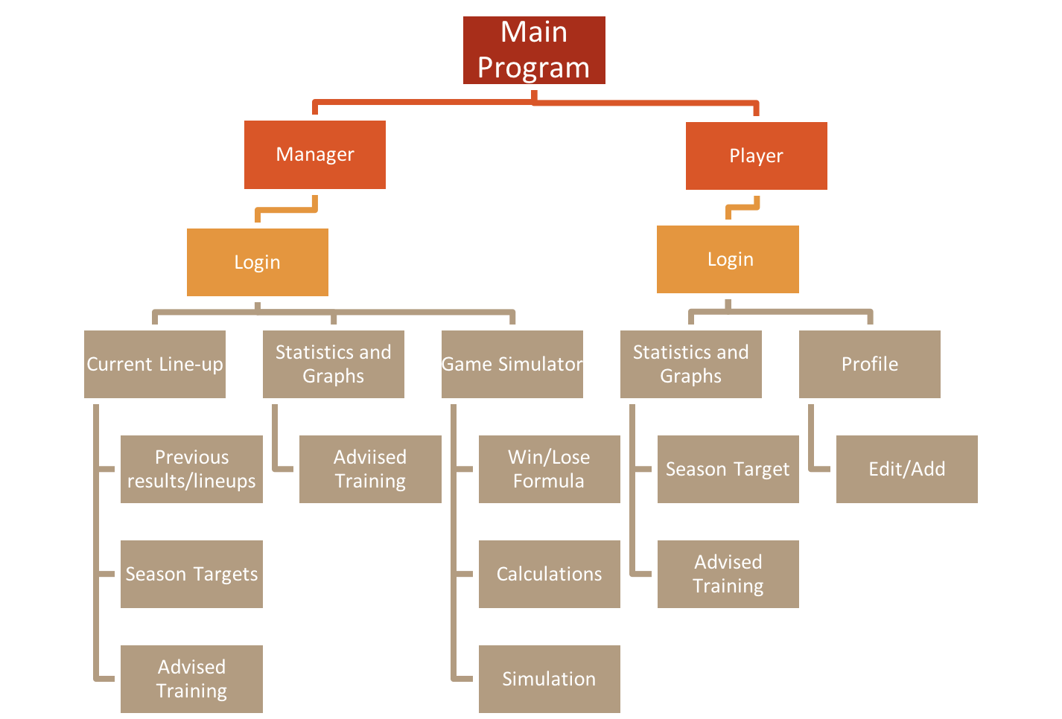

Overview of the structure of the solution

The main program is displayed by 4 screens consisting of the Main menu; Login Screen; Manager’s Screen; and Player’s Screen these are all interactive to the user and are the main ‘subprograms’ in my program. Using Abstraction and Procedural thinking it has allowed me to cut the program down from ONE big complex task to 4 main tasks that all have a simpler way to be solved but keeping the same level of complexity and shaving off parts of the program which were not valuable to the main solution of the problem.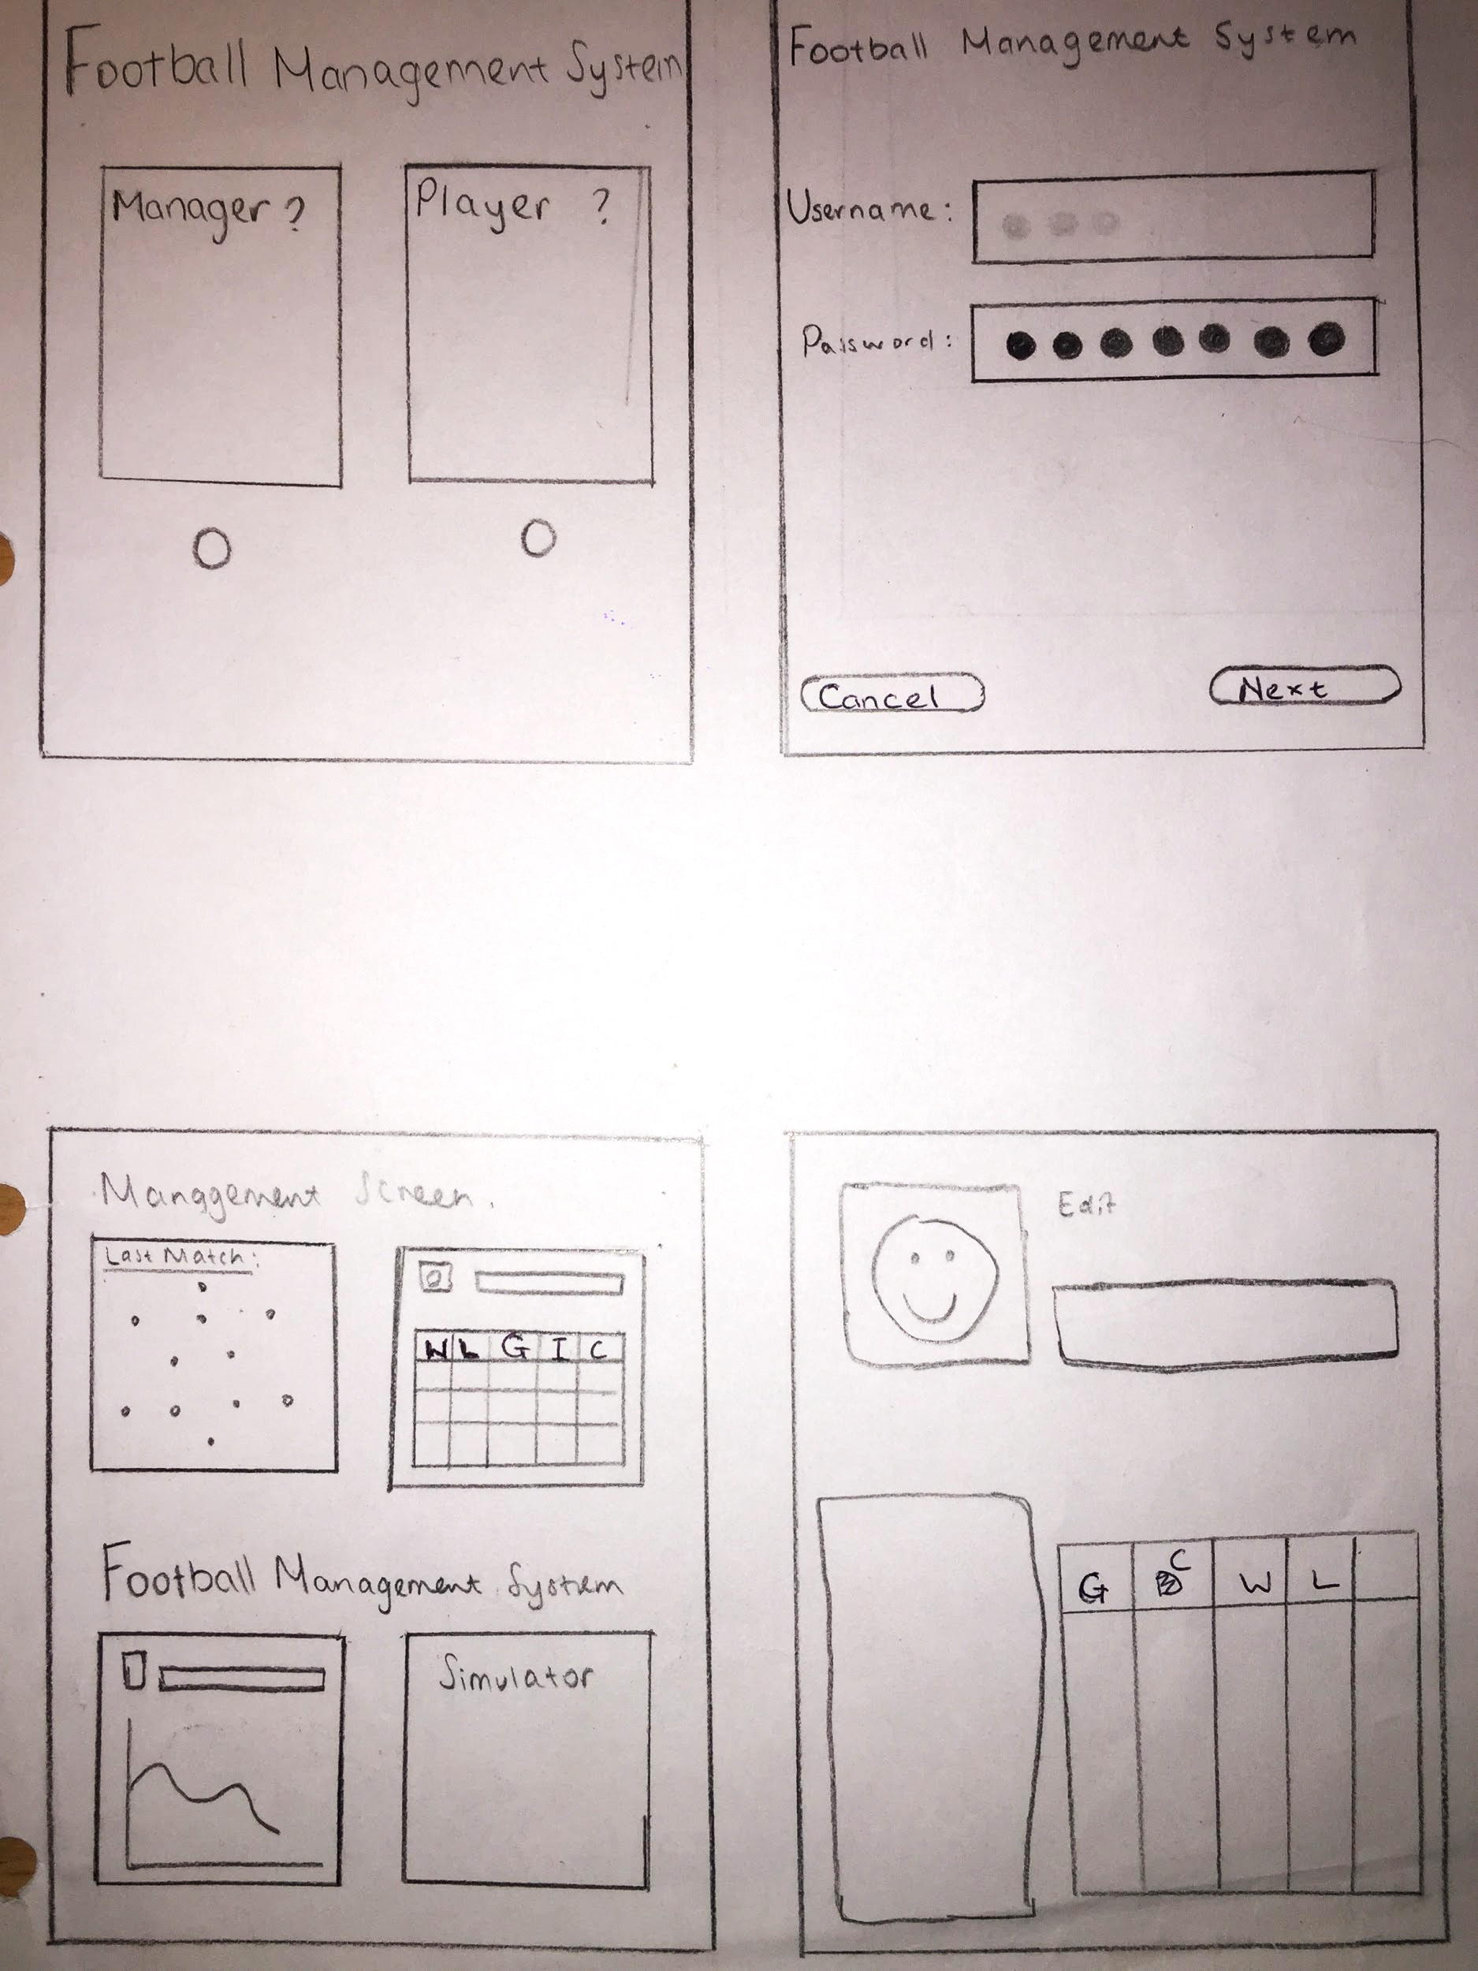

Decomposition of the problem

Main Menu Interface:



This is the main menu of the program. Here the various users can choose the pathway that caters to them (Manager or Player), this is because if they choose either one of the following steps to what option they choose out of the two. To follow the success criteria I will create a simple and easy main menu which would allow for a decision of the two to be made in less than 20 seconds.

Success criteria links:

* Simple main menu with 2 options on display
* The decision is made in the first 2 seconds

Login Interface:



This is the page that the user is sent to after they have chosen ‘Manager’ or ‘Player’ this page is common for both of the options. Moreover, the use of a login is to keep the security of the data in the Management System as the system would hold data on Players and Managers; the data is protected by the use of hashing the login details of the ‘Managers’ or ‘Players’. Hashing is one of the many ways that login details can be kept safe and secure from hackers and etc, it works by generating a unique for the password being different every time and this is used to encrypt the login details two hashing functions that could be used on the login details, in particular, the password would be:

* MD5 - Older hashing function than SHA1 and it is commonly used.
* SHA1 - Newer function and produces a longer and harder to decrypt the hash

Manager Menu Interface: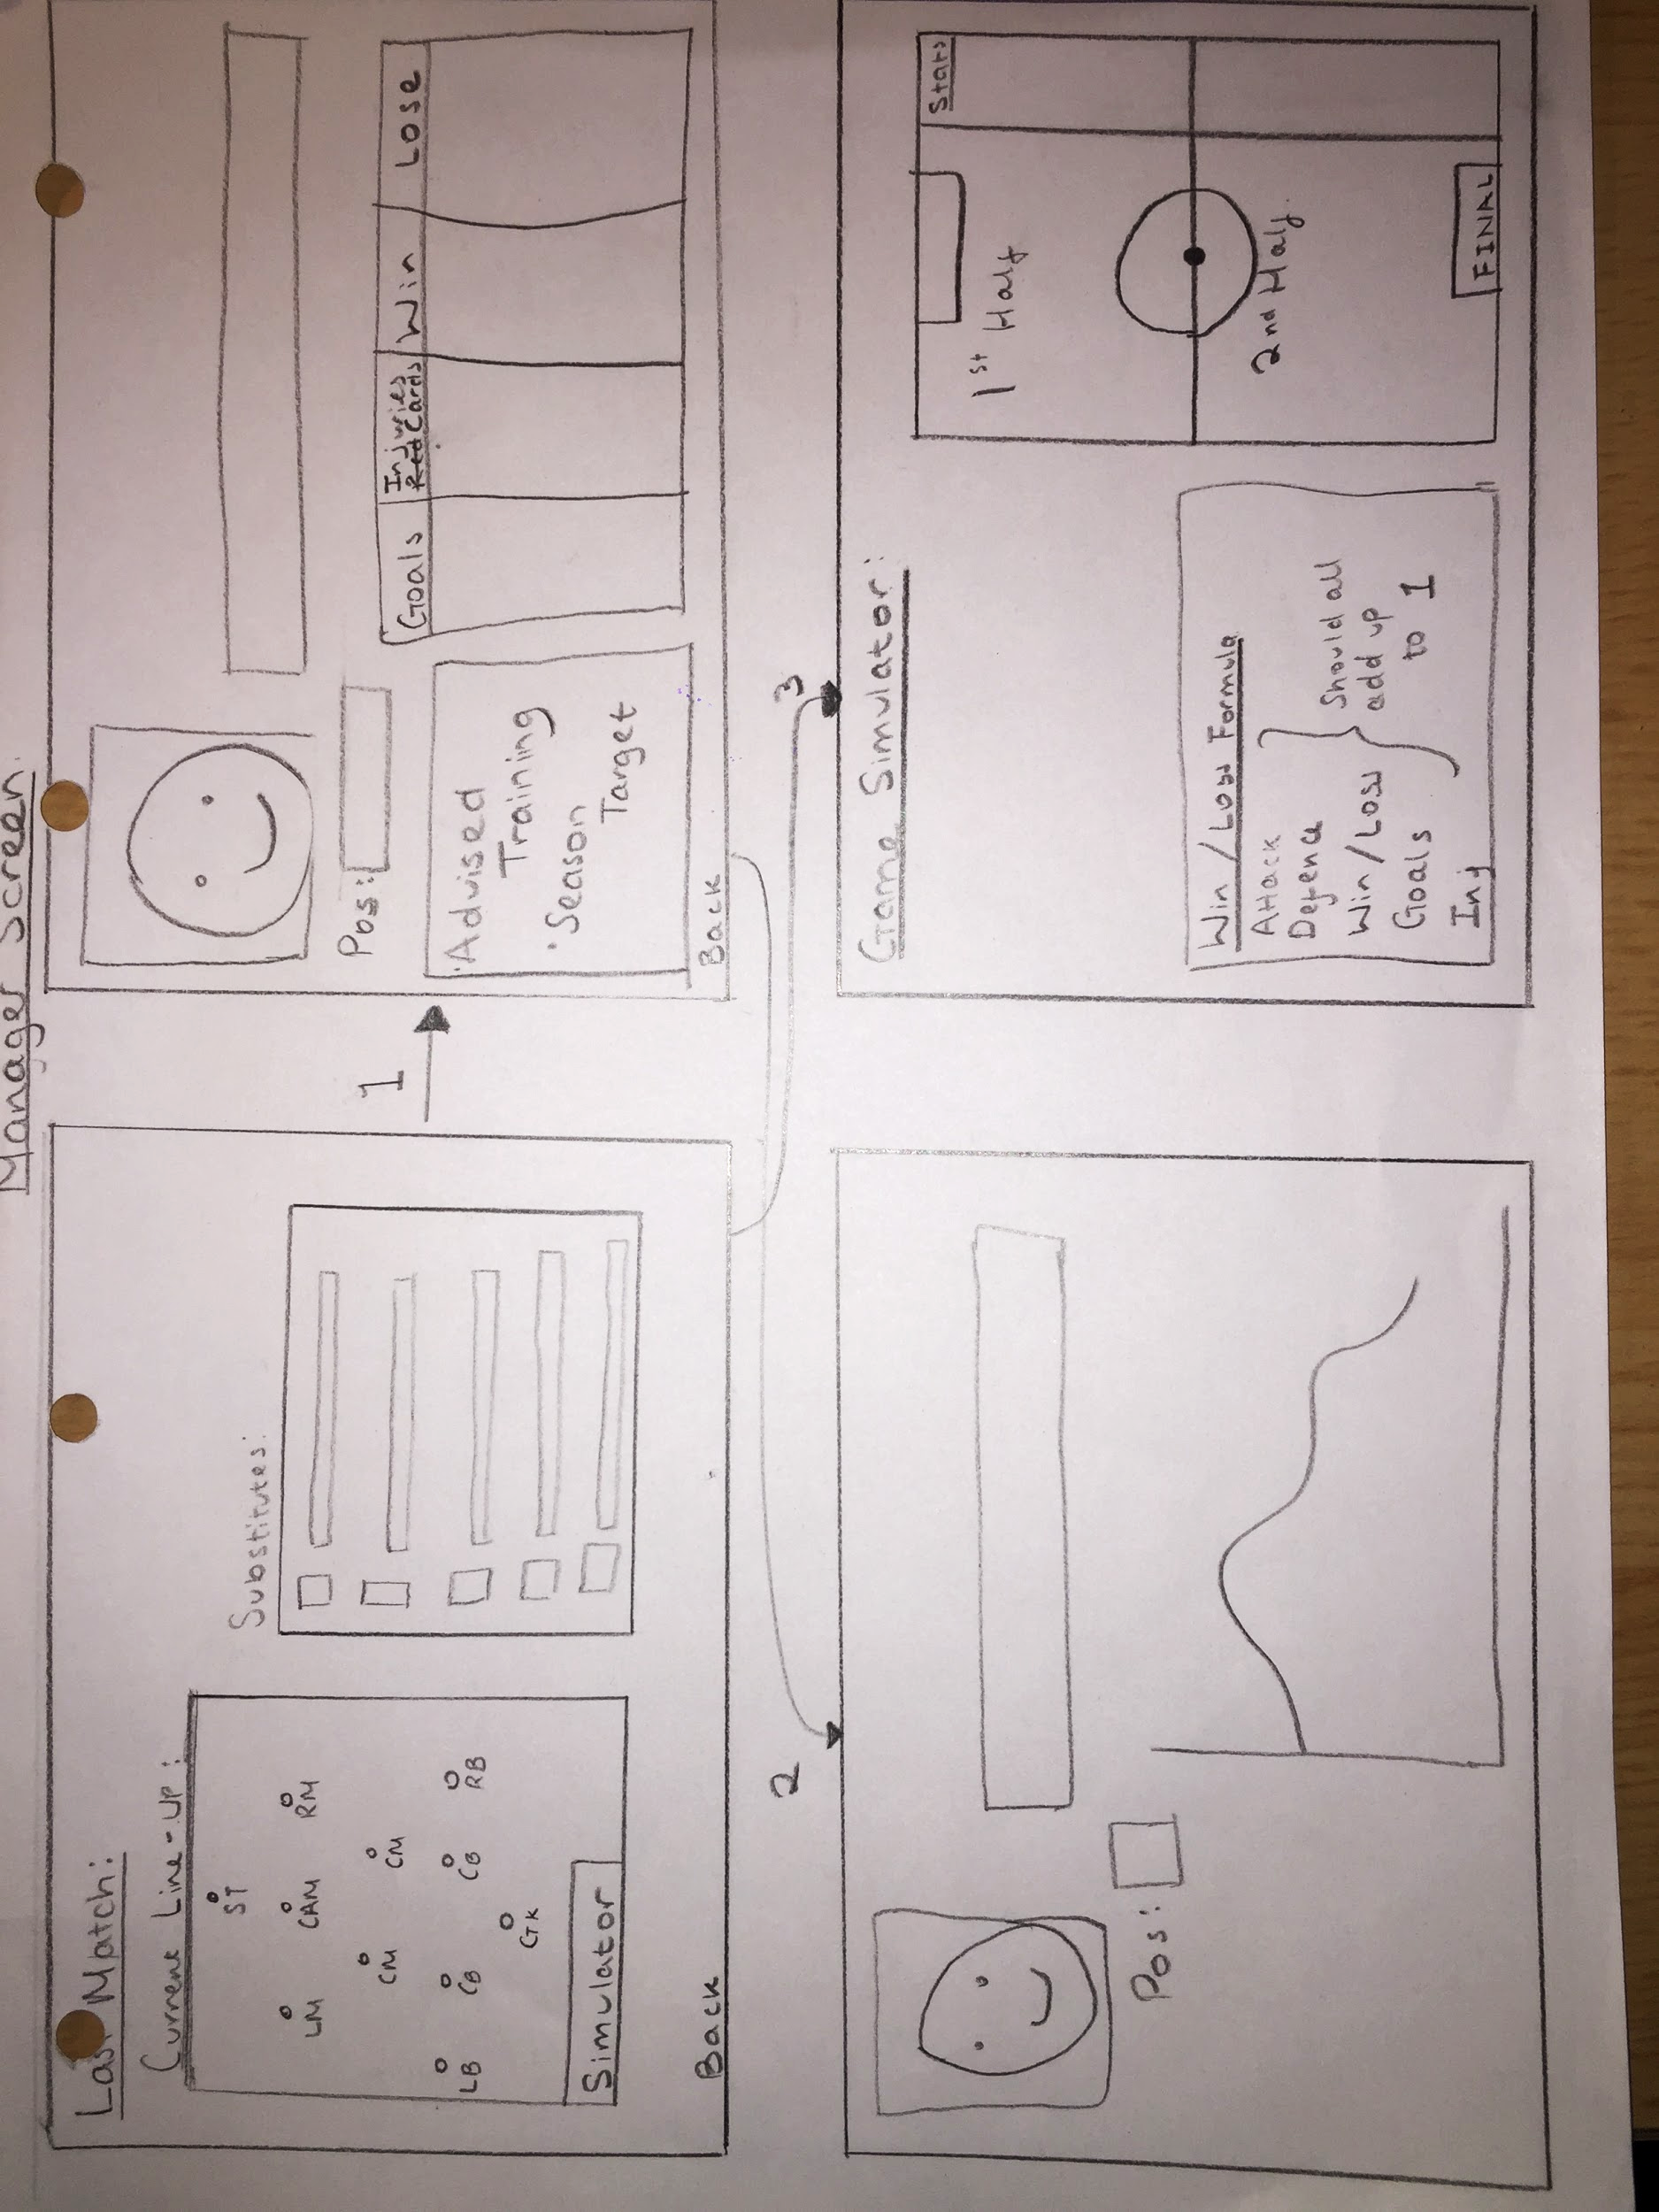

-

x -

Here is a hand drawing diagram design of the Manager’s Screen which is accessed after the managers' side of the main menu is pressed and the login details are corresponding to those stored in the database. The Managers Menu Interface displays 4 screens, Screen 1: Displays the current team line up accompanied with the substitutes and reserved players for this match; Screen 2 the top right part of the diagram displays the players statistics, season targets, and picture (this screen is a reflection of the players screen which will be explained later); Screen 3 the bottom left is the players statistics in more depth showing a graphed version of the statistics: finally Screen 4 the bottom right is the Managers gameplay simulations which are accompanied by the Win/Lose/Draw Formula which is chosen by the manager to predict future matches and this is information allows for the software to calculate a win/loss or draw based on these factors of a football game.

Player Menu Interface:

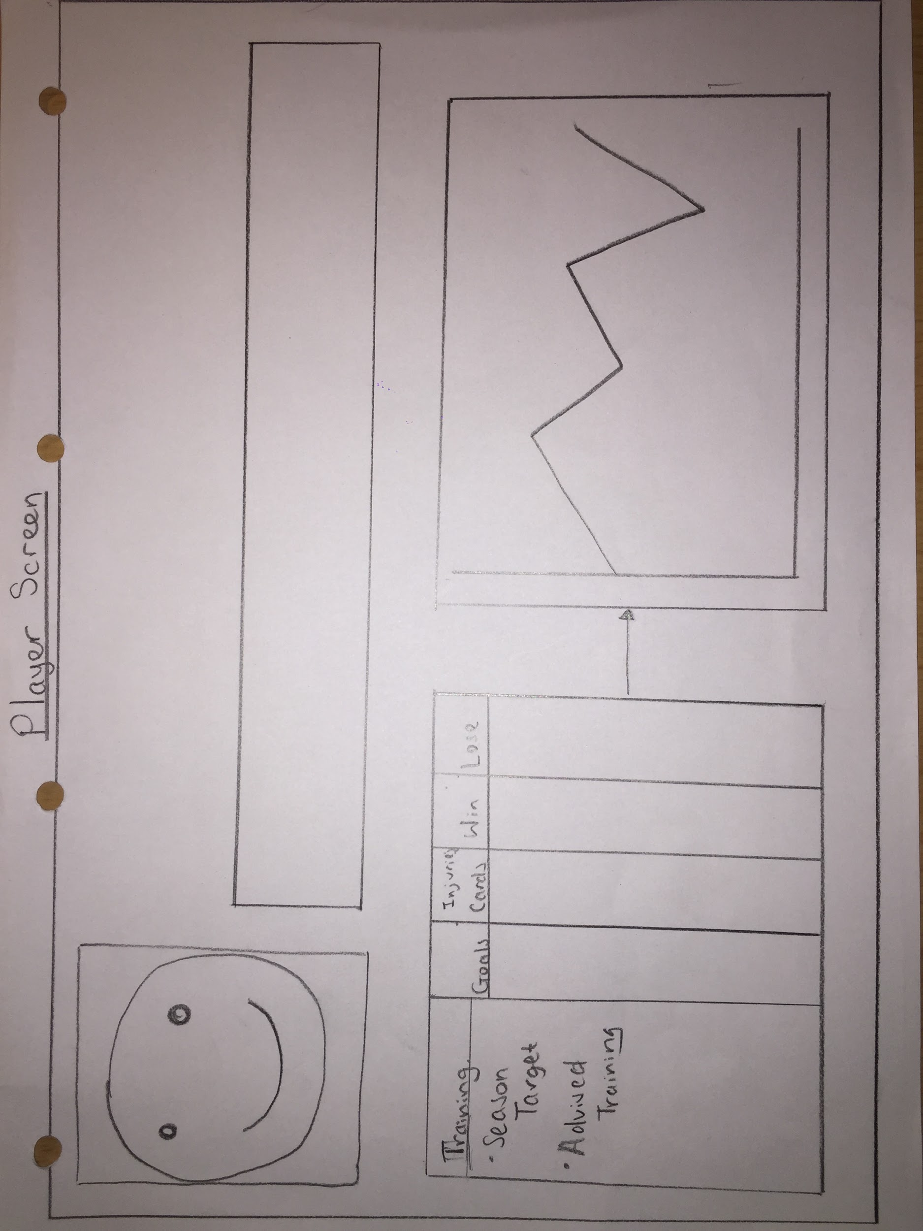

This page displays the Player Menu/Screen which shows the players statistics in a tabled or graphed format, the graphed format is adapted for each field in the tabled format of the players statistics that is pressed as this will allow for a more visual analysis of the players season performance and where they need to change as the graph will clearly show these by peaks and drops in the graph.

Flow of Football Management System

1. When the user has entered the program they will enter the Main Menu Interface, this is where the user is allowed to pick between only two options (e.g. Manager or Player) and only either or and not both of the options can be picked to follow with the success criteria.
2. The next step after selecting the Player or Manager would follow onto the Login interface. This interface allows the user to log in and accesses their Manager or Player selection and this is common to the selection of both Manager or Player to keep the data of the user confidential to the user. This will be done through hashing functions in my database where the login details are kept to keep the more secure as a hashing function make a unique hash for each users login details and cannot be decrypted.
3. Depending on whether the user has selected the manager or player option and if the login details that the user has entered a match with the current login details in the database. If this was all selected for the Manager options then the next screen that would be outputted to the user would be the Manager Menu Interface which has its own system flow:
   1. The first thing displayed on the Manager Interface would be the current team line up partnered with the substitutes and reserves from the previous match. When a player from the line-up is selected by the user this then moves onto part b.
   2. This shows the player that has been selected and their current statistics matched with their season targets and advised training. This then allows for a user to select a certain statistics to allow for them to be moved to part c.
   3. This shows the players statistics in a graphed format which is better for visualisation
   4. This part shows the match simulator partnered with the Win/Lose/Draw formula that is inputted by the user and calculated by the football management system.
4. If the user has selected the Player option and the login details are correct then the flow of that screen is as follows:
   1. If the user selects the statistics that are displayed the user will be shown a graphed display of that statistics the same as the manager would.
   2. The player can also edit their name and picture that is displayed and this would also change for the managers’ screen.

Object Oriented Programming (OOP)

Object Oriented Programming is programming language model that organises the world as a collection of objects In my project I am going use Object Oriented Programming as it caters to my program being split up into numerous sections: Manager and Player. in this case they’re called objects instead of ‘sections’.

Underline relevant objects required in project